**IF STATEMENT**

#### One of the most commonly used programming constructs is the conditional execution, or the **if statement**. This statement is used to carry out certain commands based on testing a condition. For example, you might want to execute certain commands if the condition is true, and other commands if the condition is false.

**Bash Conditional Statements**

# Conditional statement: There are total 5 conditional statement which can be used in bash programming.

* if statement
* if-else statement
* if-elif statement
* if..elif..else..fi statement (Else if ladder)
* if..then..else..fi..then..fi..fi..(Nested if)
* if statement:
* Make a directory conditional statement.

gedit if.sh (here if.sh is your file name with bash file extinction)

Input:

#! /bin/bash

echo “ Enter a Number ”

read n

if [ $n -lt 100 ]

then

echo “ $n is less than 100 ”

fi

Output:

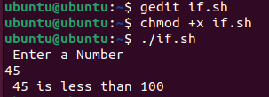 (Here chmod +x if.sh used for executable file)

* If-else statement:
* Make a new directory.

gedit ifelse.sh (here ifelse.sh is your file name with bash file extinction)

Input:

#! /bin/bash

m=1

n=1

if [ $n -eq $m ]

then

echo “ Both the variables are same ”

else

echo “ Both the variables are different ”

fi

Output:

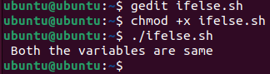

* If-elif statement:
* Make a new directory.

gedit ifelif.sh (here ifelif.sh is your file name with bash file extinction)

Input:

#! /bin/bash

echo “ Enter a Number ”

read a

if [ $a -gt 5 ]

then

echo “ Number is grater than 5 ”

elif [ $a -eq 5 ]

then

echo “ Number is equal to 5 ”

else

echo “ Number is less than 5 ”

fi

Output:

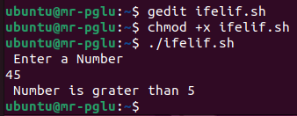

* if..elif..else..fi statement:
* Make a new directory.

gedit ifelifelse.sh (here ifelifelse.sh is your file name with bash file extinction)

Input:

#! /bin/bash

echo “ Enter your marks ”

raed mark

if [ $mark -ge 90 ]

then

echo “ Grade:- A+ ”

elif [[ $mark -le 90 && $mark -ge 80 ]]

then

echo “ Grade:- A ”

elif [[ $mark -le 80 && $mark -ge 70 ]]

then

echo “ Grade:- B+ ”

elif [[ $mark -le 70 && $mark -ge 60 ]]

then

echo “ Grade:- C+ ”

else

echo “ Grade:- F ”

fi

Output:

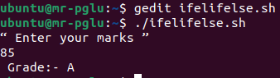

* if..then..else..fi..then..fi..fi statement:
* Make a new directory.

gedit nestedif.sh (here nestedif.sh is your file name with bash file extinction)

Input:

#! /bin/bash

echo “ Enter First Number ”

read var1

echo “ Enter Second Number ”

read var2

echo “ Enter Third Number ”

read var3

if [ $var1 -gt $var2 ]

then

if [ $var1 -ge $var3 ]

then

echo “ $var1 is the largest number ”

else

echo “ $var3 is the largest number ”

fi

else

if [ $var2 -ge $var3 ]

then

echo “ $var2 is the largest number ”

else

echo “ $var3 is the largest number ”

fi

fi

Output:

